E-voting Web Application

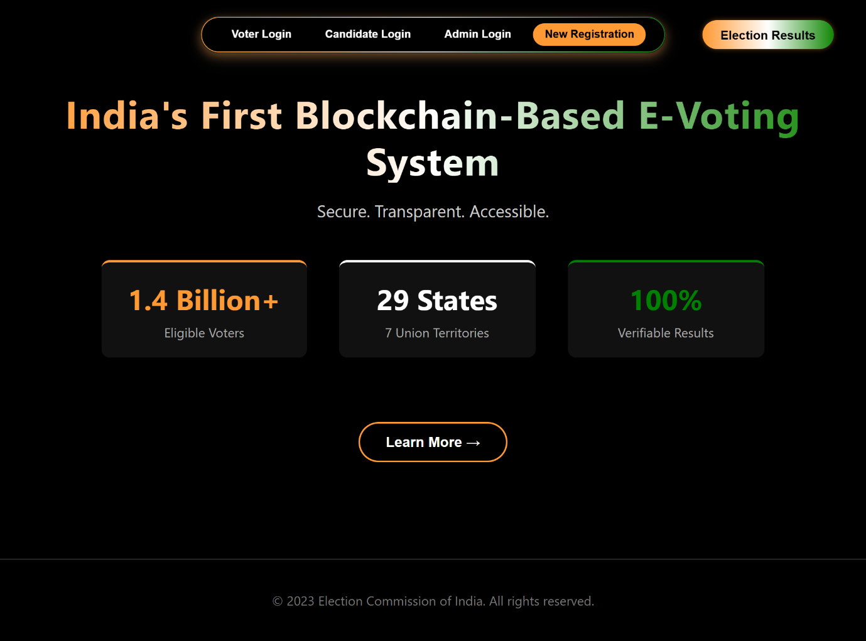

Home Page Description
The home page of the system is designed as an intuitive and streamlined interface that acts as the central access point for all users interacting with the platform. At the top section of the page, a prominent capsule-shaped navigation bar spans horizontally across the layout, giving the interface a clean, modern, and visually organized structure. Within this navigation bar, four primary functional buttons are provided: Voter Login, Candidate Login, Admin Login, and New Registration. These options are placed in a clearly structured sequence to ensure that each user type can quickly identify and access the section relevant to their role.

The New Registration button, positioned alongside the login controls, allows first-time users to create an account before participating in the system. Integrating the registration option directly into the navigation bar maintains logical and aesthetic consistency, reduces unnecessary navigation, and ensures that new users do not face any onboarding difficulty.

Aligned in the same horizontal row, immediately beside the navigation bar, is an additional standalone button labeled Election Result. This button provides direct access to the results of the conducted elections, enabling users—whether registered or unregistered—to conveniently view outcomes without navigating through internal pages. Its placement ensures that election results remain transparent, easily accessible, and distinctly separated from login-related functionalities.

The central area of the home page is used to present introductory information regarding the platform’s purpose, workflow, and key features. This ensures that visitors gain a foundational understanding of how the system operates before proceeding further. The textual content is strategically structured to maintain readability while enhancing the overall professional appearance of the page.

Towards the bottom of the home page, a Learn More button is provided to guide users to extended details about the system, including its objectives, design considerations, and operational flow. This button acts as a transition point between the brief overview on the home page and the more comprehensive documentation available in the subsequent sections.

Overall, the home page layout ensures a balanced combination of functionality and design. The placement of critical navigation buttons, the clear role-based entry points, the accessibility of election results, and the structured informational flow collectively contribute to a user-friendly interface suitable for academic evaluation, professional presentation, and placement-oriented project demonstrations.

Section Transition
After understanding the layout and functionality of the home page, the next part of this report focuses on explaining each major component accessible from the main interface. Every button on the home page represents a dedicated module of the system, and each module contains specific features tailored to the role of the user interacting with it. To present the workflow in a structured and systematic manner, the following sections describe the purpose and internal contents of all five functional buttons: Voter Login, Candidate Login, Admin Login, New Registration, and Election Result.

Since the voting process begins with user authentication, the detailed explanation starts with the Voter Login module. The upcoming section outlines the structure, functionality, and operations associated with the voter’s portal, providing a clear understanding of how a registered voter interacts with the system.

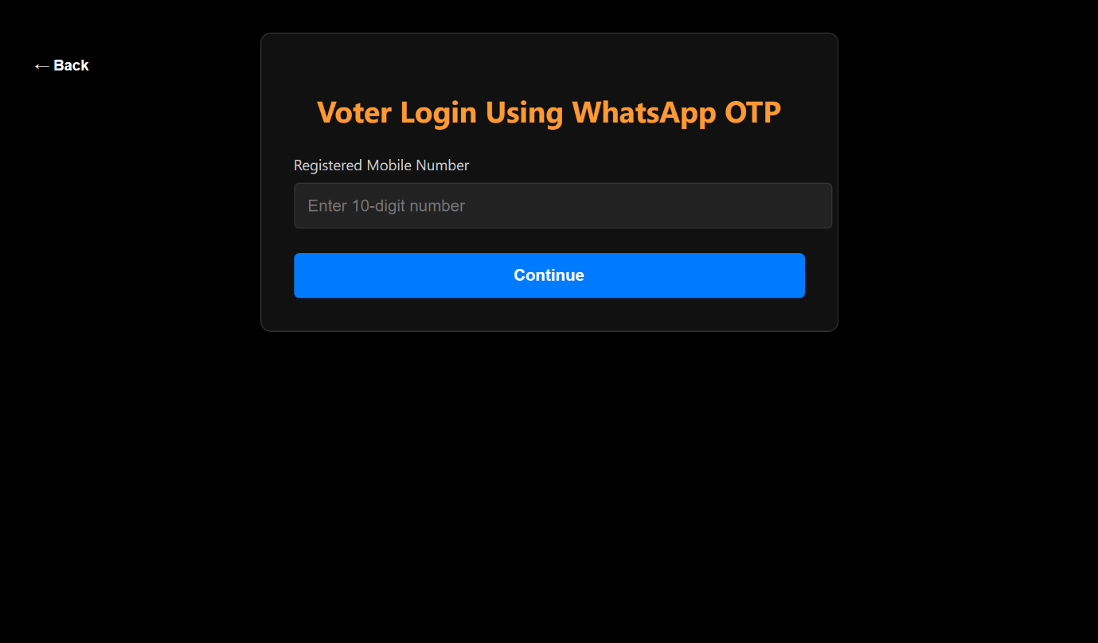

Voter Login
Following the main homepage interface, the first functional module of the system begins with the Voter Login section. This part of the platform is designed to provide secure and streamlined access for registered voters. The image displayed for this section shows a dedicated login box that appears at the center of the page, ensuring that the user’s attention is directed immediately to the authentication process.

The login interface consists of a single input field where the voter is required to enter a 10-digit mobile number. This mobile number serves as the primary identifier for voter authentication within the system. The minimalistic design helps maintain clarity and reduces the chances of input errors, ensuring that the login process remains simple, quick, and user-friendly. The system validates the entered mobile number before allowing the voter to proceed to the next step, thereby maintaining security while keeping the interface intuitive.

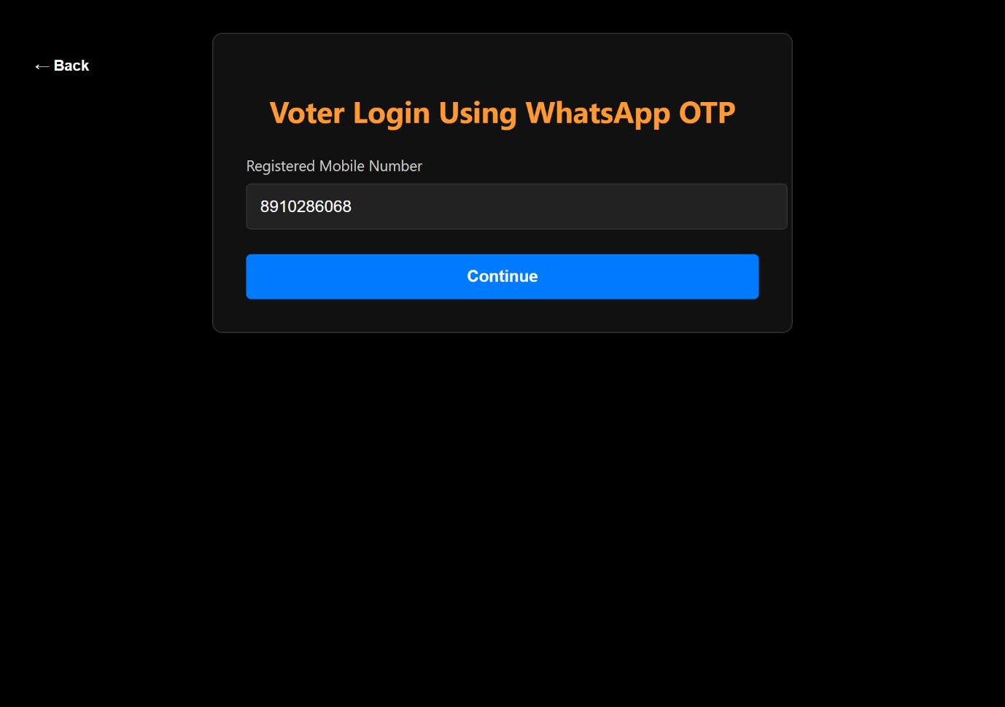

Voter Login
The second image displays the same voter login interface after the user has successfully entered their 10-digit mobile number into the input field. This step confirms that the system has received the required login credential and is ready to move the voter forward in the authentication workflow. Once the mobile number is entered in the correct format, the user can click the Continue button, which initiates the transition to the next stage of the voter validation process. This interaction ensures that only users with a valid mobile number can advance further, maintaining both structure and security within the system’s login mechanism.

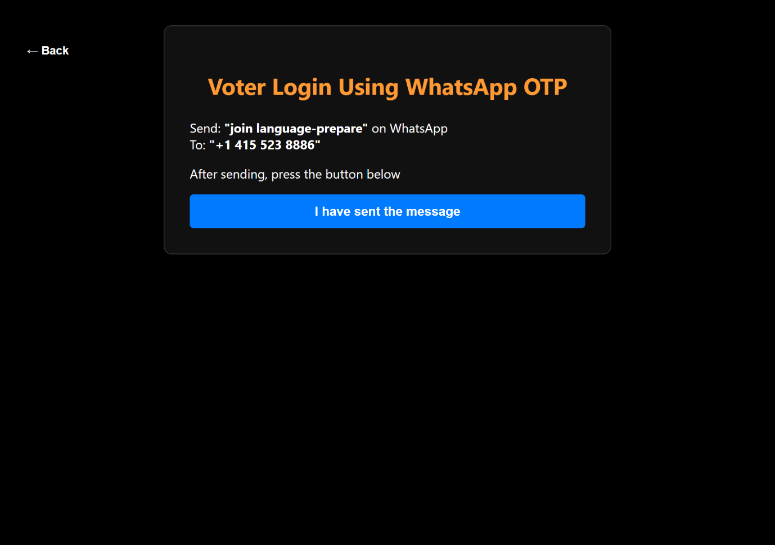

Voter Login
The next screen displayed in the voter login process introduces an alternative verification method titled “Voter Login Using WhatsApp OTP”, which appears as the heading at the top of the interface. This page guides the voter through the steps required to authenticate their identity using WhatsApp instead of the traditional SMS-based OTP mechanism. The instructions shown in the image clearly direct the voter to send the message “join language-prepare” to the WhatsApp number +1 415 523 8886, which is a Twilio-powered WhatsApp sandbox number used for testing and secure verification.

Below the instructions, the interface provides an action button labeled “I have sent the message”, allowing the voter to confirm that they have completed the required step. Once pressed, the system processes the voter’s confirmation and advances them further into the login flow. The layout in the image makes the verification steps easy to follow, ensuring that the voter understands exactly how to complete the WhatsApp-based authentication process before proceeding.

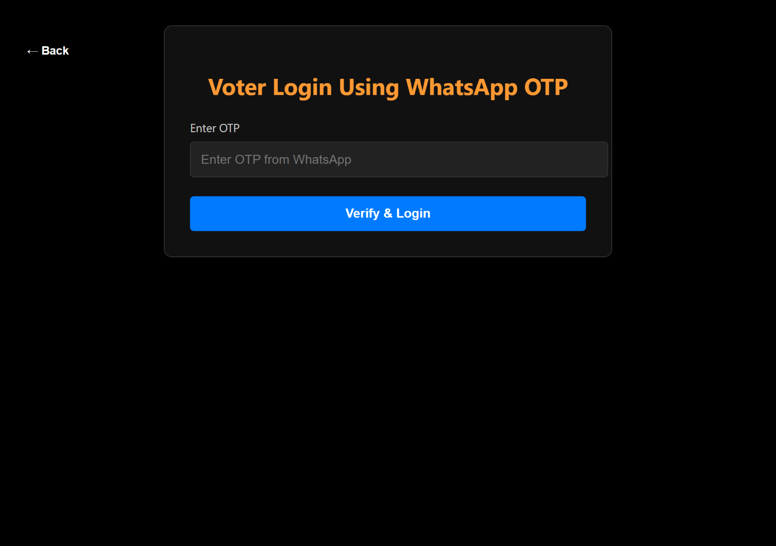

Voter Login
The next screen displayed to the voter is the OTP verification interface, which appears immediately after the WhatsApp message has been successfully sent and confirmed. This page contains a dedicated input field where the voter is required to enter the One-Time Password (OTP) received through WhatsApp. The layout is simple and focused, ensuring that the user’s attention remains on the verification step. The OTP field is centrally positioned so the voter can quickly enter the code and proceed without confusion.

Below the OTP input box, there is a confirmation button that allows the voter to submit the entered code and continue to the next phase of the authentication process. This screen plays a crucial role in validating the voter’s identity securely before granting access to voting-related features within the system.

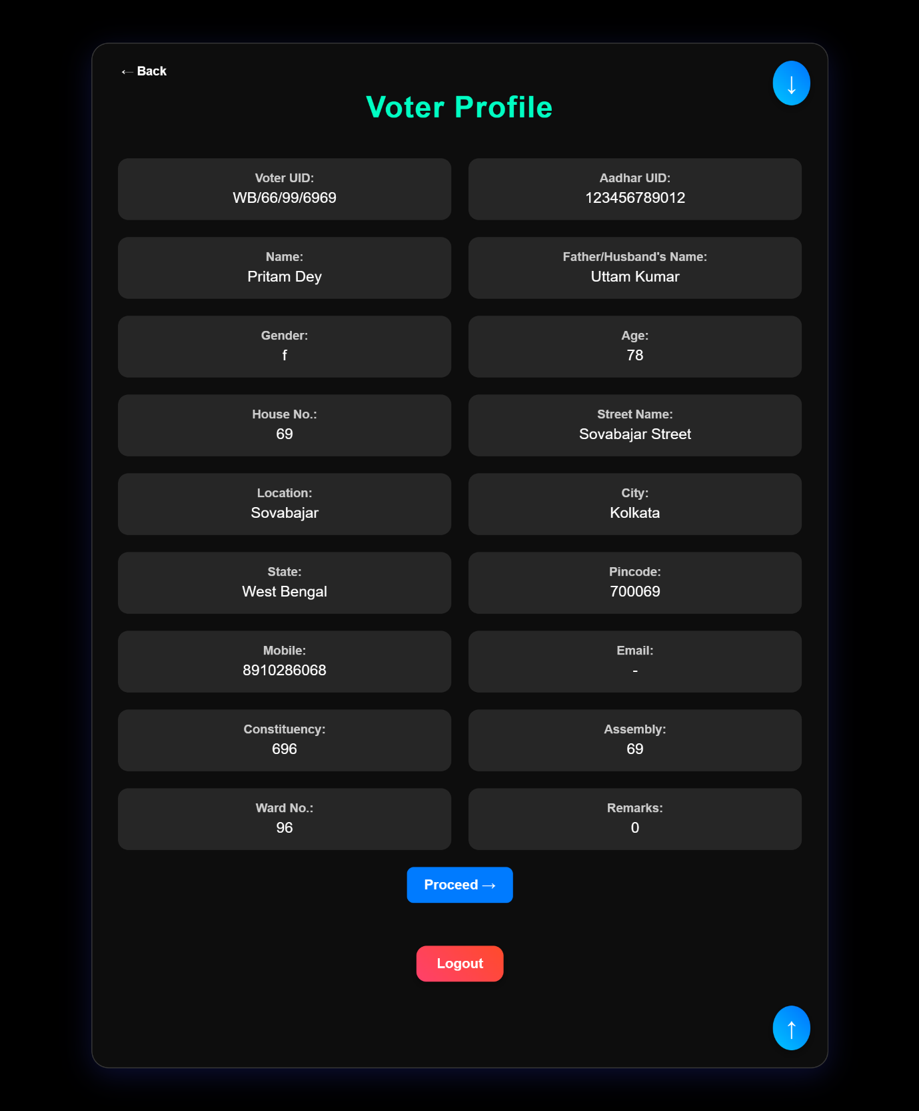

Voter Login
The final image in this sequence displays the voter’s profile dashboard, which becomes accessible only after a successful OTP verification. The page shows the voter’s complete registered details, organized clearly for easy review. Personal information such as the voter’s name, contact details, identification number, and other relevant fields are neatly arranged within the interface.

At the top of the page, a Scroll to Bottom button allows the voter to instantly navigate to the lower section of the profile, while a Scroll to Top button is positioned at the bottom to facilitate quick return navigation. These utility controls are especially useful when viewing detailed profiles with multiple fields. Additionally, a Logout button is provided on the page, enabling the voter to securely exit their account once they have reviewed their information. The layout emphasizes user convenience, security, and clarity, ensuring a smooth experience after successful authentication.

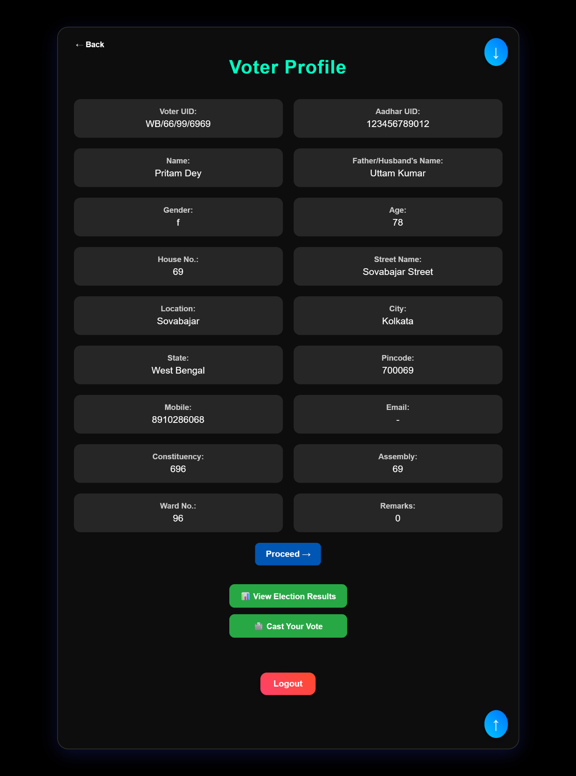

Voter Login
After pressing the Proceed button on the voter login page, the interface presents the voter with two options in the next step. The first button, View Election Result, provides access to the election results page. The second button, Cast Your Vote, allows the voter to cast their vote in the ongoing election. Both buttons lead the user to the same subsequent page, offering flexibility in navigation depending on the voter’s immediate intent. This design ensures that voters can easily choose their desired action after logging in, maintaining a smooth and intuitive user experience.

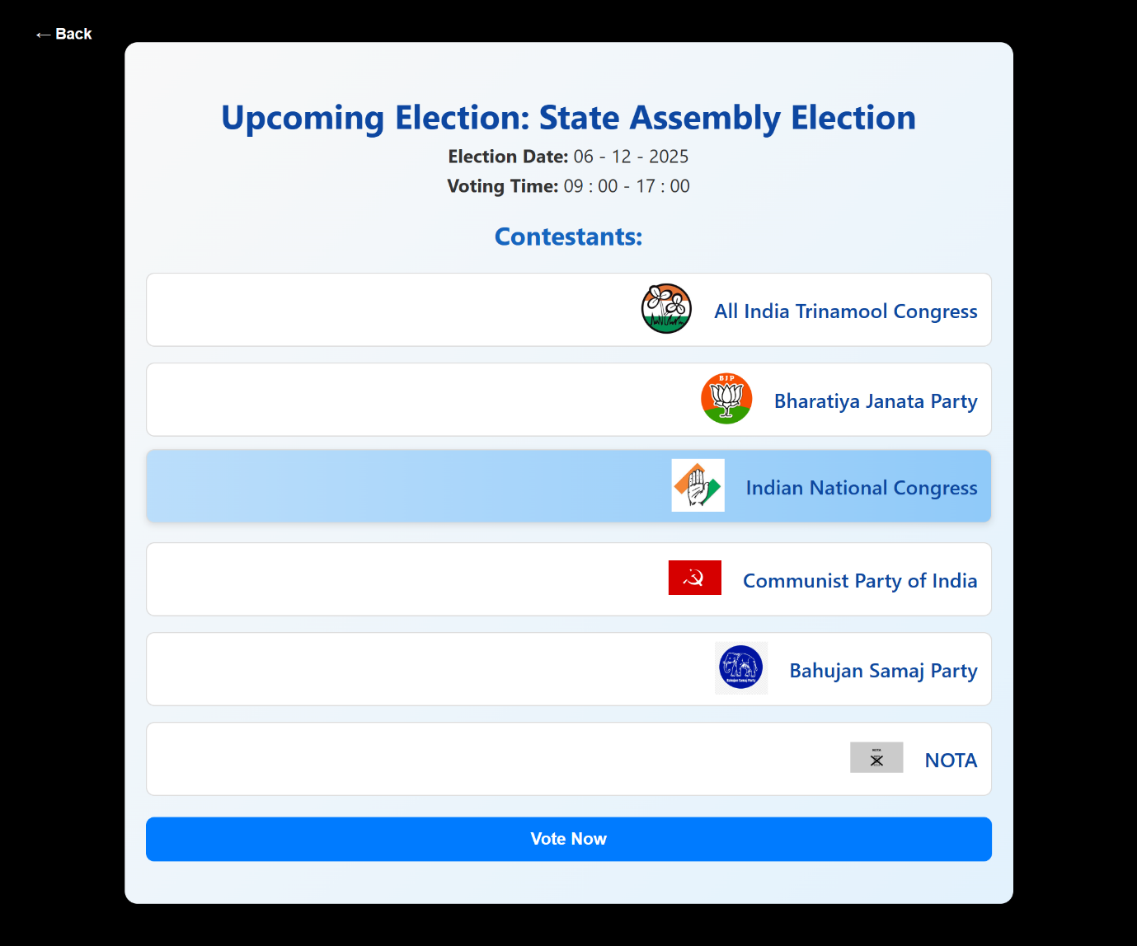

Voter Login
This page displays the list of all political parties participating in the election, providing the voter with a clear overview of the options available. Each party is listed along with relevant details to help the voter make an informed choice. At the top or within the interface, the Election Date and Time are prominently displayed, ensuring that the voter is aware of the schedule. A Vote Now button is also provided, allowing the voter to proceed directly to cast their vote. The layout is designed to be intuitive and informative, guiding the voter smoothly from party selection to the voting process.

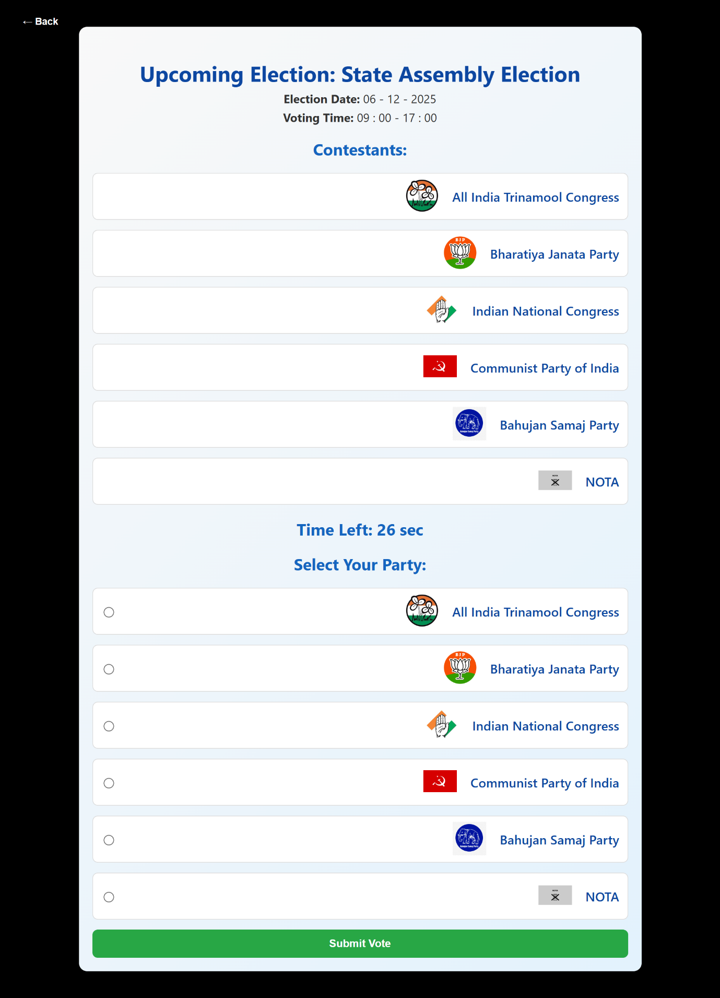

Voter Login
Once the voter clicks on the Vote Now button, a new voting window opens, which is active for a limited duration of 30 seconds. Within this window, the voter must select their preferred party from the listed options or choose NOTA (None of the Above) if they do not wish to vote for any party. After making a selection, the voter confirms their choice by pressing the Submit Vote button. It is important to note that if the voter does not submit their vote within the 30-second time frame, the system automatically registers the vote as cast, and the voter will not be able to participate in that particular election again. This time-bound process ensures a secure and efficient voting procedure, maintaining the integrity of the election.

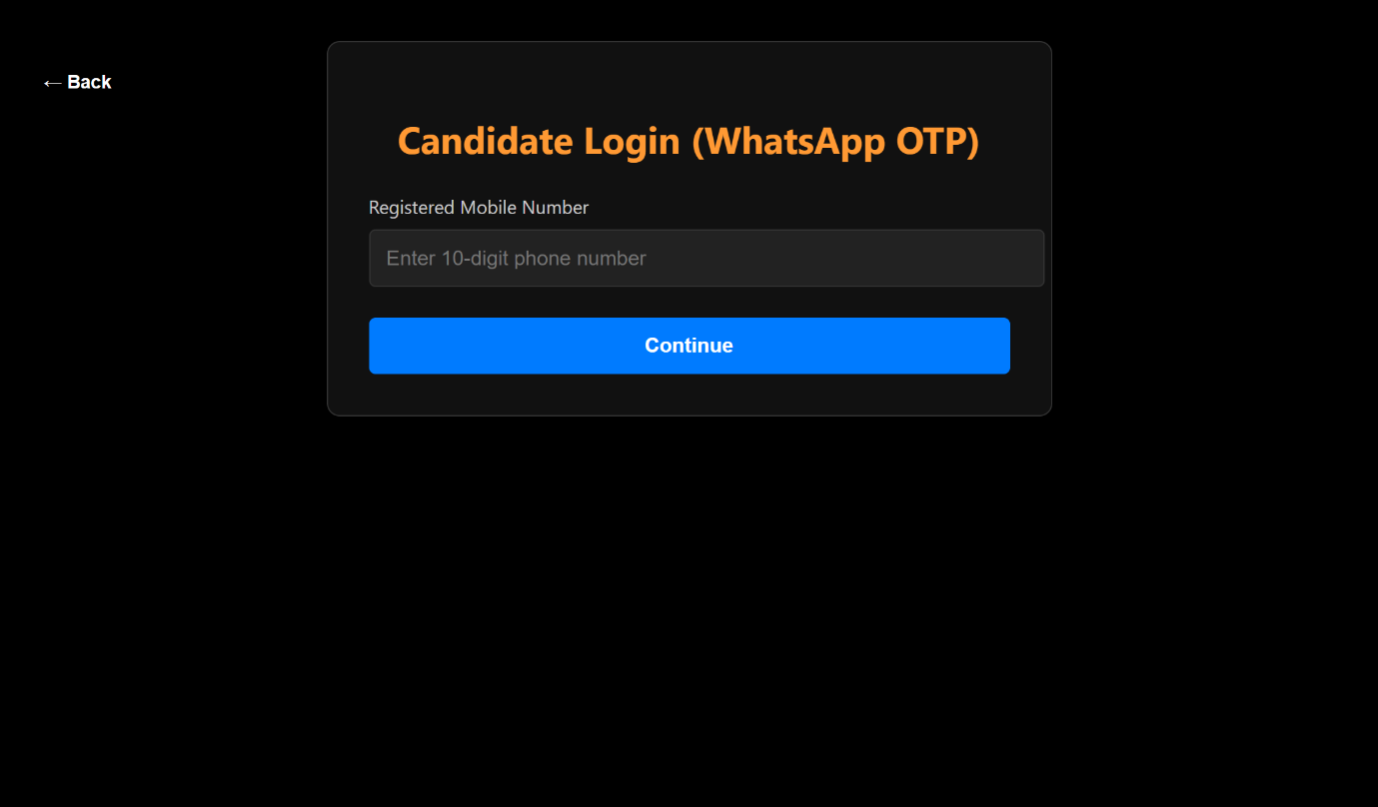

Candidate Login
The candidate login interface is designed to allow registered candidates to access their portal securely. Similar to the voter login, the candidate is required to enter their 10-digit mobile number in the input field provided. This ensures that only verified candidates can proceed to the next steps, maintaining the authenticity and security of the platform. The layout is simple and intuitive, guiding candidates to quickly enter their credentials and continue to their respective dashboard.

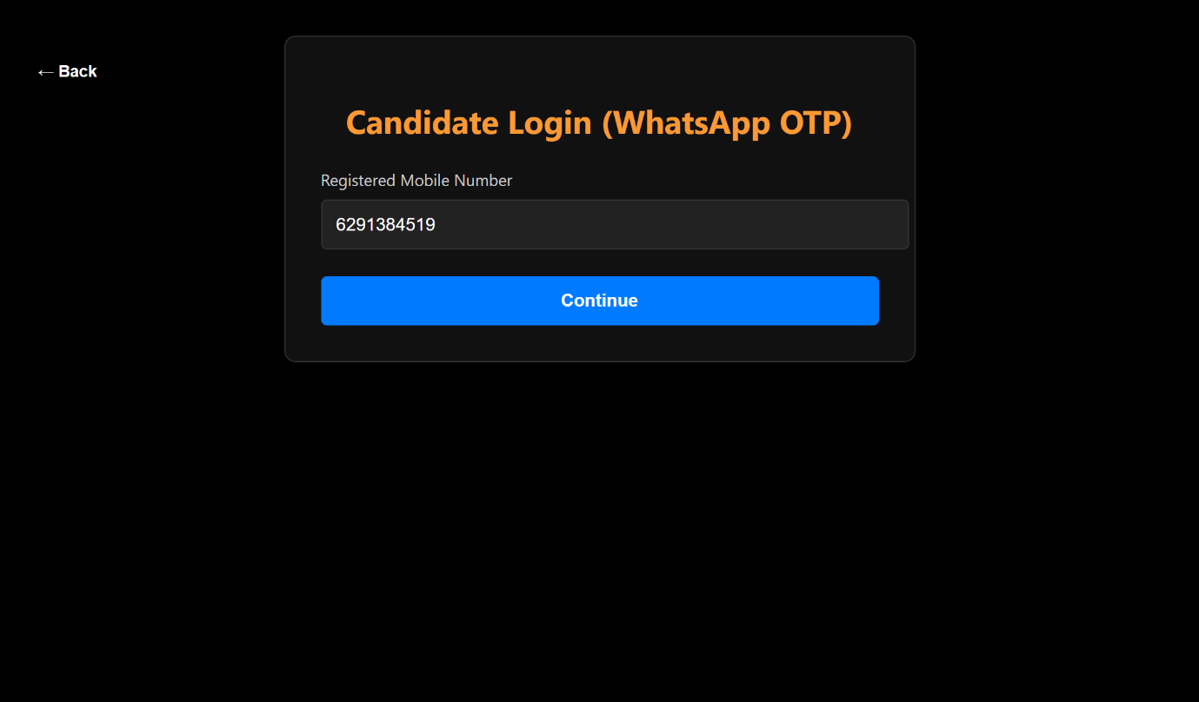

Candidate Login
After entering the 10-digit mobile number in the candidate login field, the candidate can press the Continue button to proceed to the next step. This action verifies that a valid number has been entered and moves the user forward in the login process. The interface is designed to be straightforward, ensuring that candidates can easily navigate without confusion and reach their dashboard efficiently.

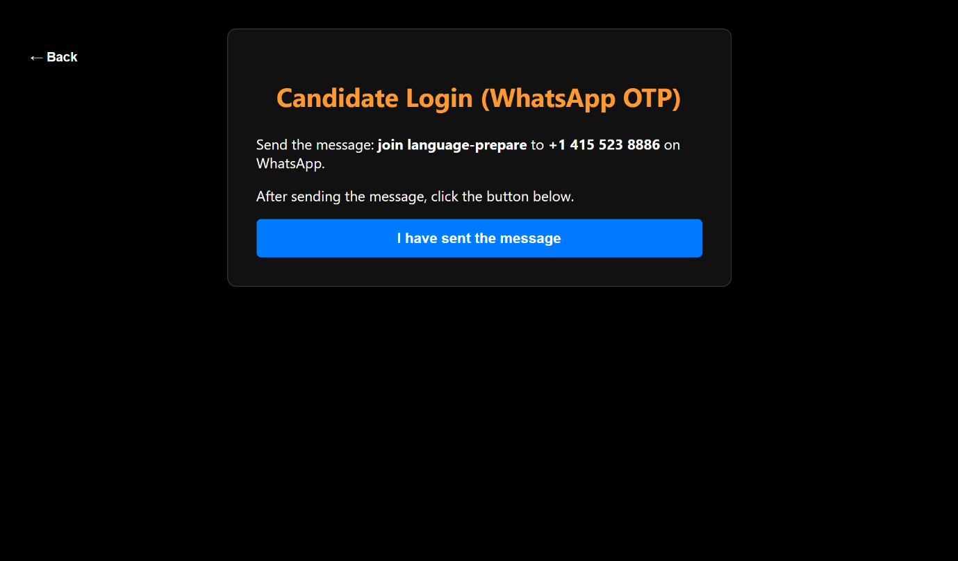

Candidate Login
Once the candidate has entered their mobile number, the system prompts them to complete verification using a WhatsApp OTP. The page provides clear instructions to send the message: "join language-prepare" to the number +1 415 523 8886. After sending the message via WhatsApp, the candidate confirms by pressing the I Have Sent the Message button. This step ensures secure authentication of the candidate before granting access to the portal. The use of a WhatsApp-based OTP mechanism adds an extra layer of security while keeping the process simple and user-friendly.

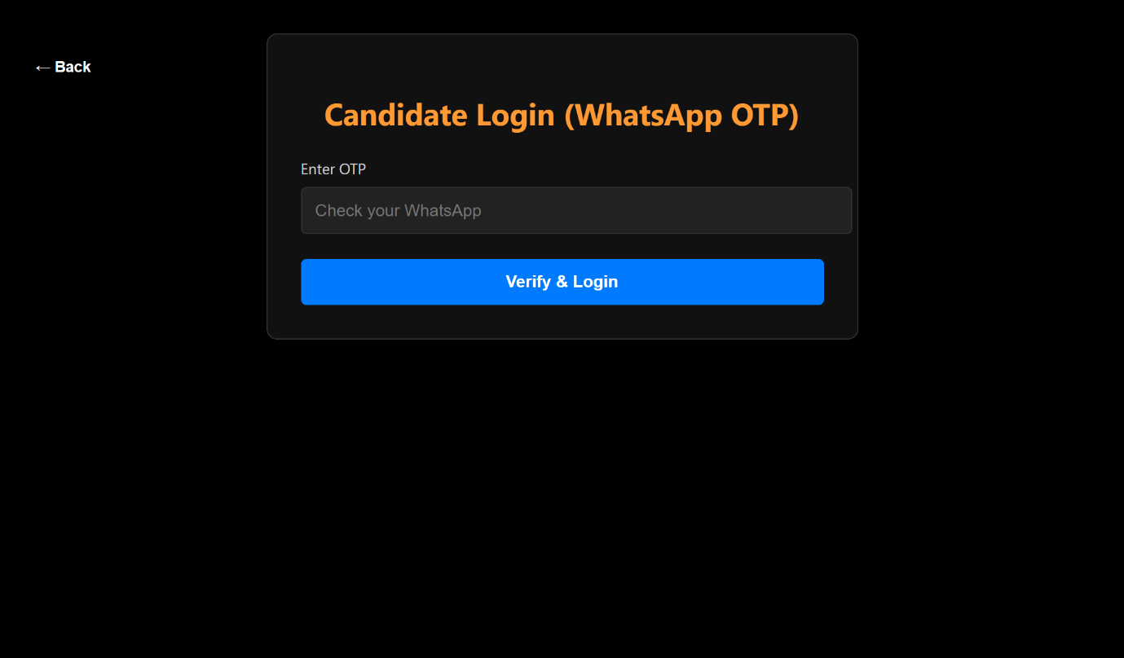

Candidate Login
After confirming that the WhatsApp message has been sent, the candidate is directed to the OTP (One-Time Password) Entry screen. Here, the candidate must input the OTP received on their WhatsApp to verify their identity. This step ensures that only authorized candidates can access their portal, maintaining the security and integrity of the election system. The interface is simple and clear, allowing candidates to quickly enter the OTP and proceed to their dashboard.

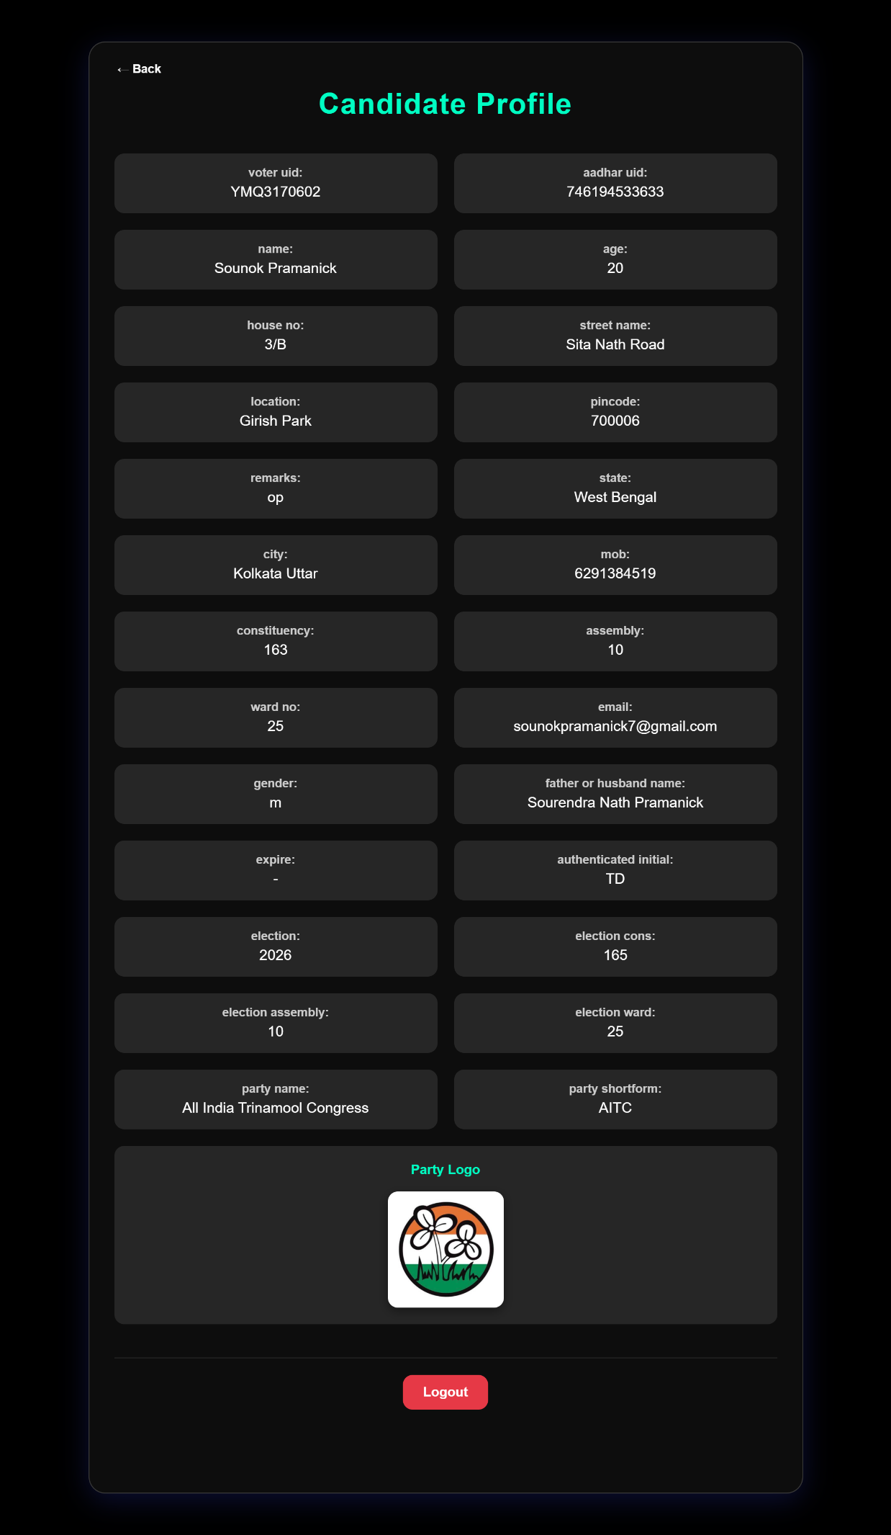

Candidate Login
Once the candidate has successfully logged in, they are directed to their dashboard, which provides a comprehensive view of their profile. This page displays all relevant details about the candidate, including their personal information and affiliation with a political party. The party’s name and logo are clearly shown to provide a visual identifier alongside textual information.

The interface also includes a Logout button for secure exit from the portal. For easier navigation through the profile, a Scroll to Bottom button is placed at the top of the page, and a Scroll to Top button is available at the bottom. These features enhance user convenience, allowing the candidate to quickly navigate through the entire profile without excessive scrolling, creating a smooth and user-friendly experience.

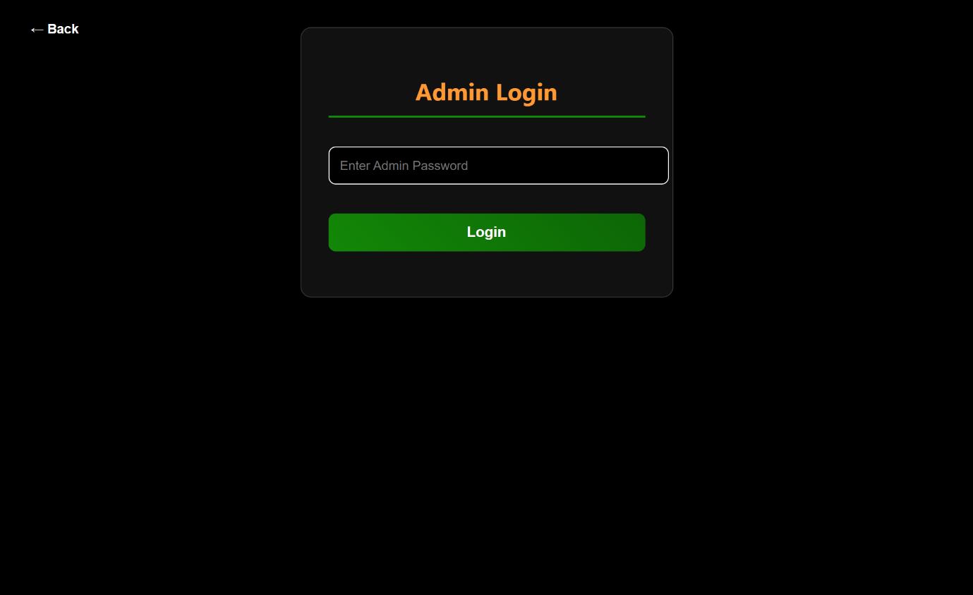

Admin Login
The admin login interface is designed to provide secure access to the administrative panel. The page features a single input field where the predefined password must be entered. Once the password is input, the admin can press the Login button to access the system. If the entered password is correct, the admin is granted access to the dashboard; otherwise, an error message is displayed, preventing unauthorized entry. This secure authentication mechanism ensures that only authorized personnel can manage and monitor the election system, maintaining the integrity and safety of the platform.

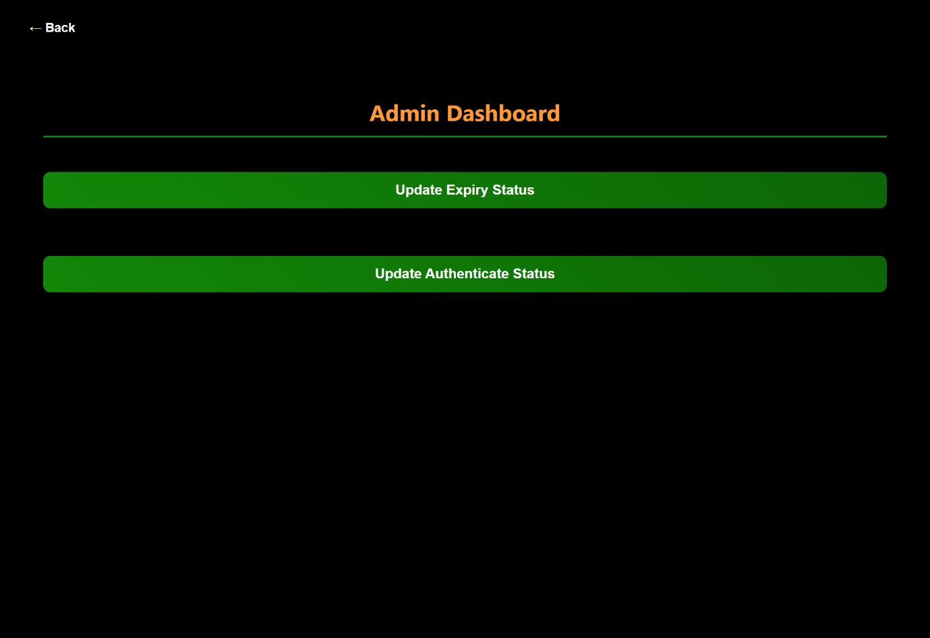

Admin Login
After successful login, the admin is directed to the dashboard, which provides access to essential administrative functions. The dashboard features two main buttons: Update Expiry Status and Update Authenticate Status.

The Update Expiry Status button allows the admin to manage voter records, including marking a voter as expired if necessary. This ensures that only eligible voters are able to participate in the election.

The Update Authenticate Status button is used to verify and approve new user registrations. Only after the admin authenticates a new user through this function can that user log in using their mobile number. This verification process helps maintain the integrity and security of the election system by ensuring that all users are properly authorized before accessing the platform.

The dashboard layout is straightforward, making it easy for the admin to quickly perform these critical functions.

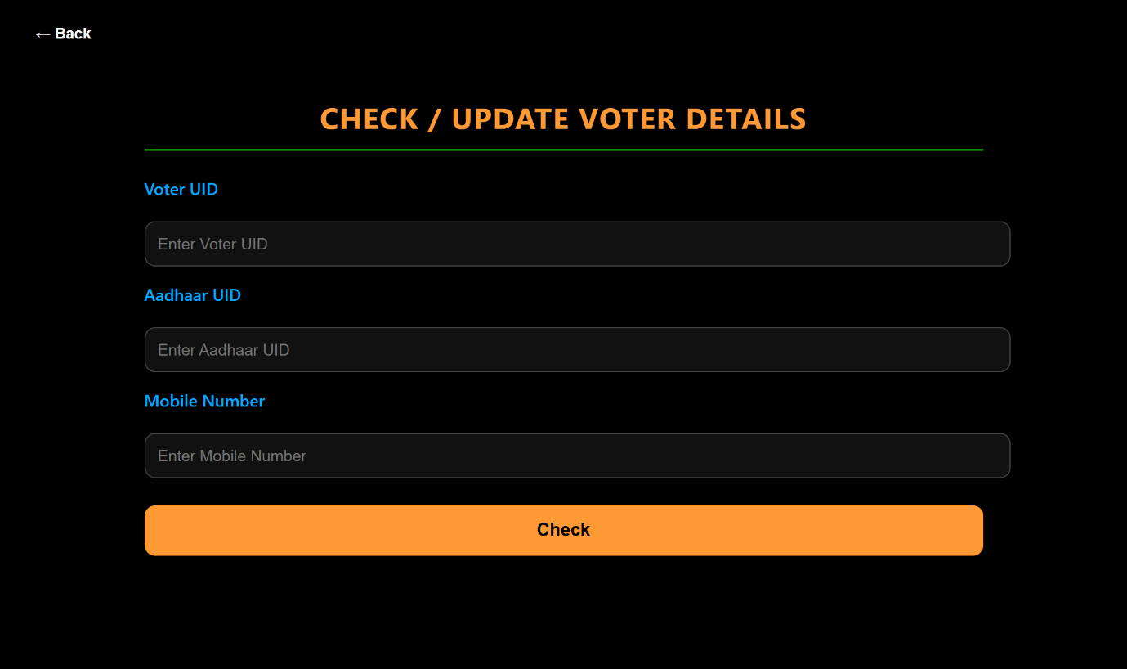

Admin Login
Inside the Update Expiry Status section of the admin panel, the interface provides a search system that allows the admin to locate any voter efficiently. The page presents three unique identifiers through which a voter can be searched: Aadhar ID, Voter ID, or Mobile Number. Since each of these values is unique to every individual, the admin can easily pinpoint the exact voter record without confusion. This precise search method ensures accurate updates to voter status and helps maintain the reliability of the overall system.

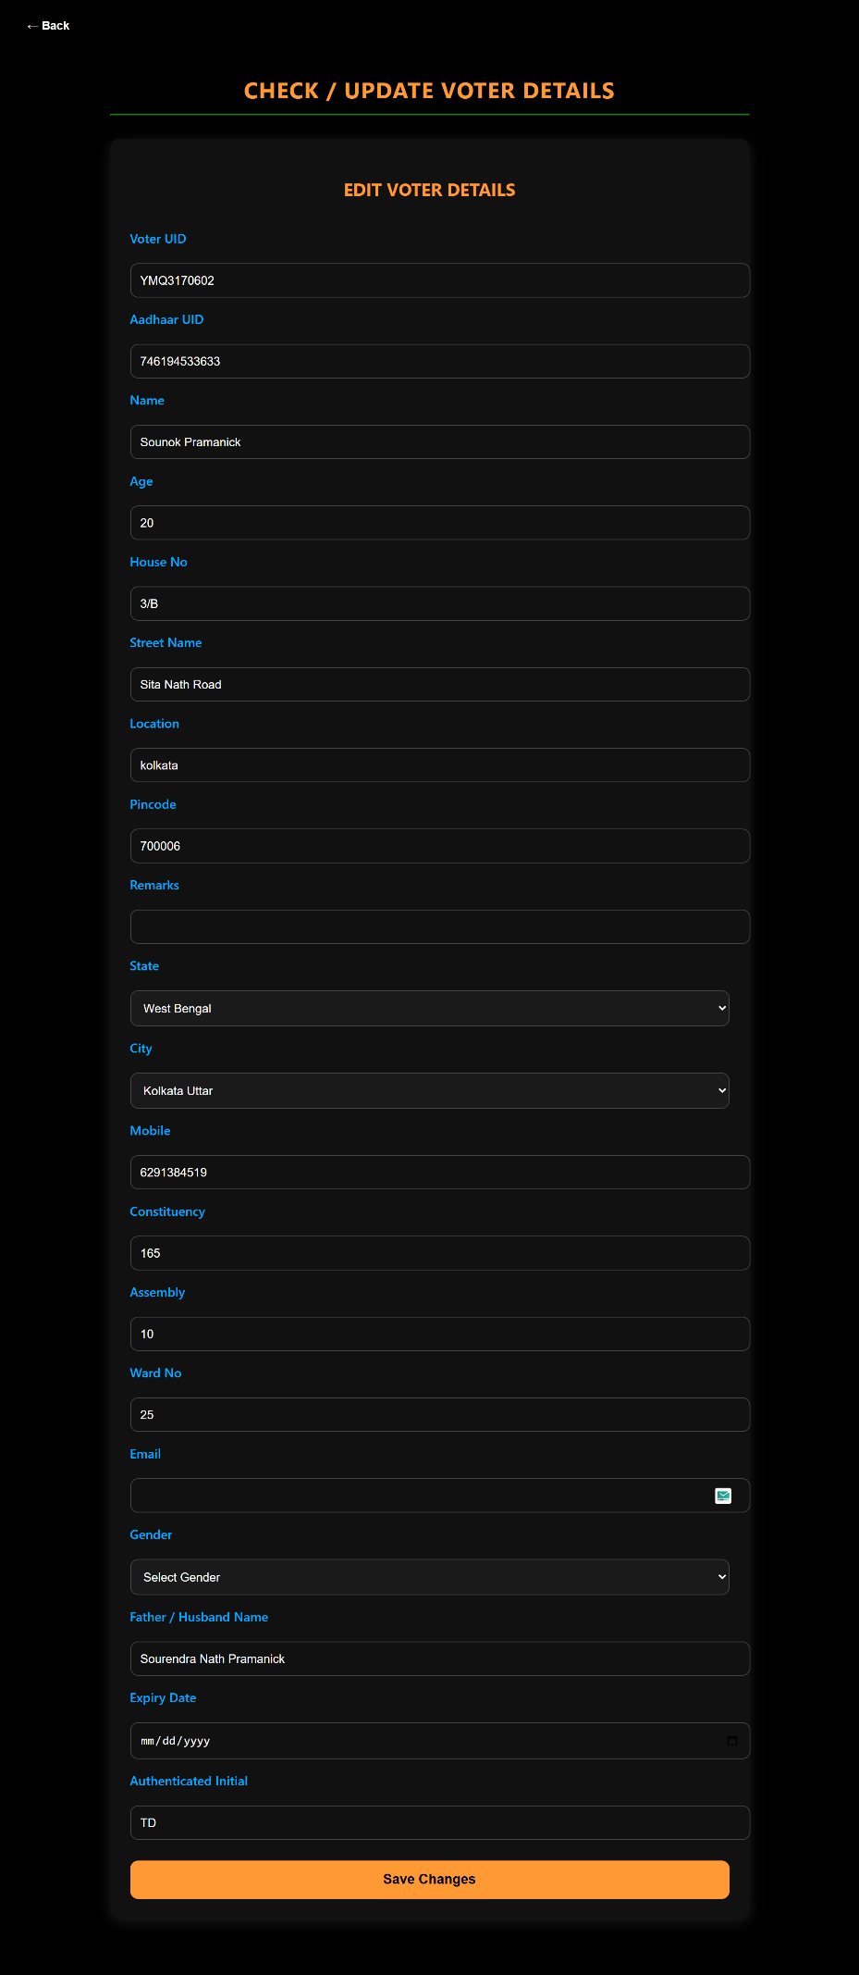

Admin Login
After the admin searches for a voter using either the Aadhar ID, Voter ID, or Mobile Number, the system displays the complete profile of the selected individual. All relevant information about the voter becomes visible on this screen, giving the admin full control to review and modify the data whenever required.

The admin can update any field within the voter’s record, including personal details, contact information, or status-related fields. This page also allows the admin to mark a voter as deceased by entering the appropriate date of expiry in the designated field. Once all necessary corrections or updates are made, the admin can finalize the changes by clicking the Save Changes button.

This functionality ensures that voter records remain accurate, up-to-date, and properly maintained within the system.

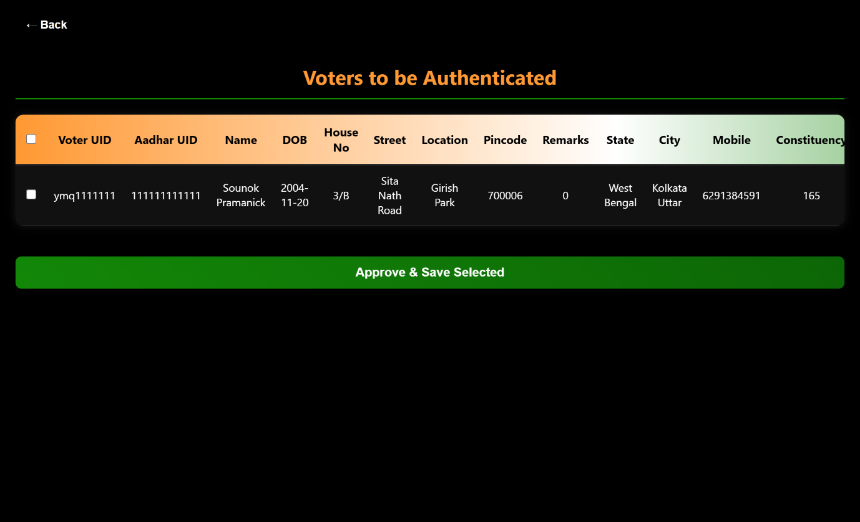

Admin Login
In the Update Authenticate Status section of the admin dashboard, the administrator can review all pending user registrations that have not yet been approved. Every new registration entry is displayed horizontally in a structured format, showing the complete details of each applicant. This layout allows the admin to easily scan through all pending records and verify their authenticity before adding them to the main database.

The interface provides options to select individual records or select all entries at once, making the authentication process efficient for both small and large batches of registrations. After choosing the records that are ready for approval, the admin finalizes the process by clicking the Approve and Save Selected button. Once approved, these records are removed from the temporary storage and transferred to the main database, officially registering the users in the system. Only after this authentication step can new users log in using their mobile number and access their accounts to participate in the voting process.

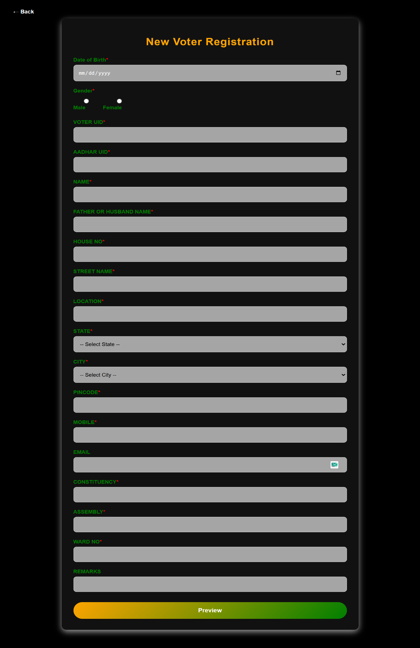

New Registration
The New Registration section opens with a comprehensive form that collects all the essential information required to create a new voter record. This form aligns directly with the database structure shown in the table, where certain fields are mandatory for successful registration. Key details such as voter ID, Aadhar ID, name, date of birth, address information, mobile number, constituency details, and other personal data must be provided accurately.

To maintain data integrity and prevent incorrect entries, several validation checks are applied to the form. The Voter ID must follow a specific format, beginning with three alphabetic characters followed by seven numeric digits. The Aadhar ID is strictly limited to 12 digits, ensuring compliance with the official identification standard. The Date of Birth field includes an age validation mechanism that permits registration only if the applicant is at least 18 years old, confirming their eligibility to vote. The Pincode field requires exactly six digits, matching postal regulations.

For better user experience and to minimize errors, the State field is implemented as a dropdown menu. Once a state is selected, the City dropdown automatically updates to display only the cities belonging to that selected state, simplifying the selection process and ensuring accurate geographic data. All these structured inputs collectively ensure that the information entered is consistent, validated, and ready for administrative review.

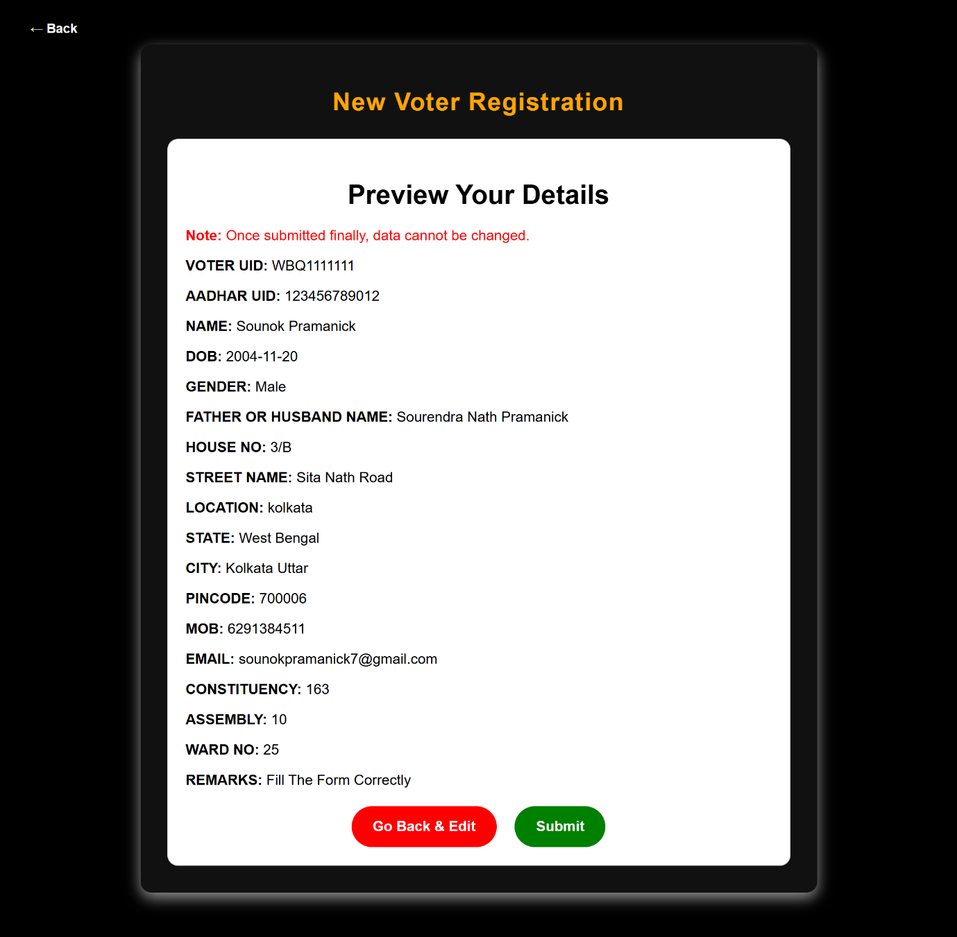

New Registration
After the user completes the New Registration form, the system displays a Preview Page summarizing all the information that was entered. This page allows the user to carefully review each detail, including personal information, address, identification numbers, and other required fields. At this stage, the user is given two options:

- Edit Details – This option allows the user to go back and correct or update any information if they notice an error or wish to make a change.

- Final Submit – Once the user confirms that all the details are accurate, they can press the final submission button. After this confirmation, the registration data is officially recorded and sent to the admin’s authentication panel.

This preview step ensures that the user has full control over their data and helps minimize mistakes before the information enters the system, contributing to cleaner and more reliable records.

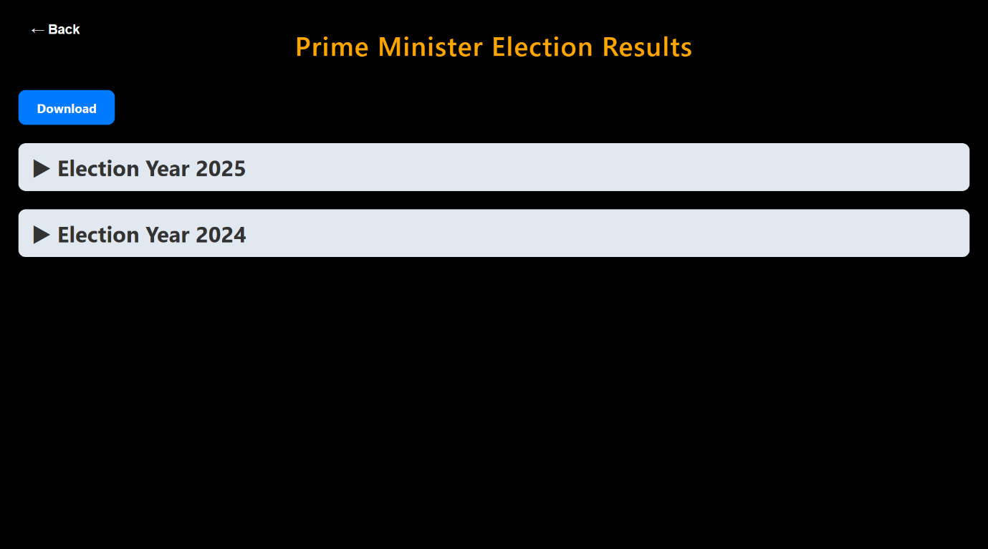

Election Results
This section of the website provides a comprehensive and well-structured interface for viewing election results across different years. The page organizes all available results year-wise, allowing the user to expand any specific year to explore the detailed outcome of that election cycle. Once expanded, the results are presented in multiple layers for clarity and depth, including:

- Overall Election Results for the entire region
- Ward-wise Results under each assembly
- Assembly-wise Results under each constituency

To enhance understanding, the page includes graphical representations, such as charts and visual summaries, making it easier to interpret trends and voting patterns. Additional analytical data is also provided, including:

- Total Poll Percentage
- NOTA Percentage
- Male Poll Percentage
- Female Poll Percentage
- Other relevant voting statistics

At the bottom of the section, a Download Results button is available, enabling users to save or review the election data offline. This feature ensures ease of access for students, administrators, and professionals who may need these results for reporting, auditing, or analytical purposes. The layout is designed to present complex information in an organized manner, making the section both informative and user-friendly.

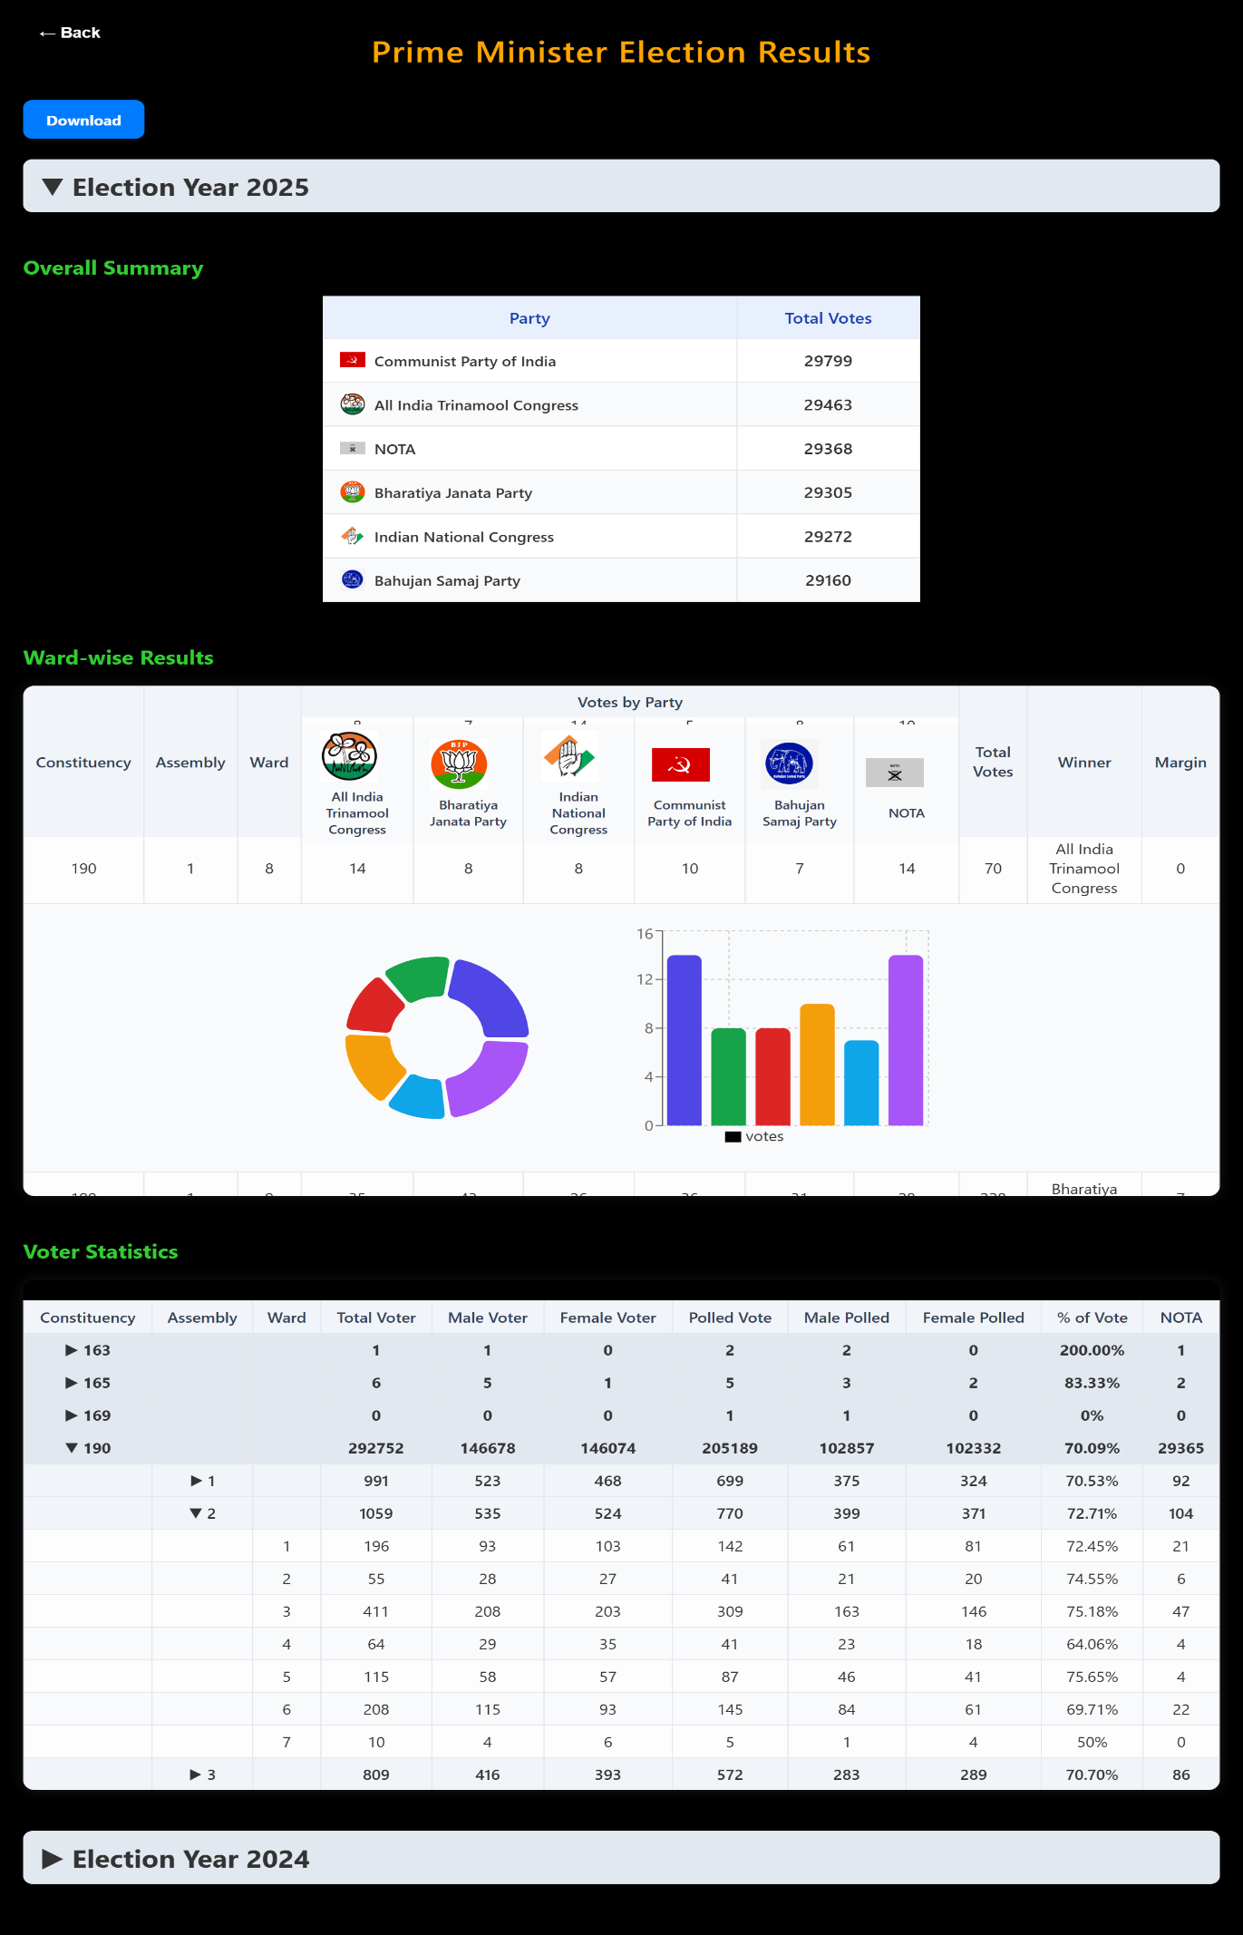

Election Results
A structured table lists all participating political parties alongside their respective total votes. Each row includes the party's logo, the party name, and the total number of votes received, offering a quick high-level comparison of performance across parties.

Ward-wise Results
This section breaks down voting data at a more granular level for each ward under a specific constituency and assembly. It includes:

- A table displaying parties, number of votes received per party, total votes, winner, and winning margin.
- Visual charts including a donut chart and a bar graph, illustrating vote distribution among parties in an easy-to-understand graphical format.

Voter Statistics
This extensive section provides a detailed breakdown of voter demographics and polling behavior across constituencies, assemblies, and wards. For each segment, the following details are shown:

- Total voters
- Male voters
- Female voters
- Total polled votes
- Male polled votes
- Female polled votes
- Voting percentages
- NOTA count

This section is structured using expandable tables, allowing users to collapse or view detailed information ward-by-ward or assembly-by-assembly for a selected constituency.

At the bottom, a similar collapsible section is provided for Election Year 2024, indicating that results for multiple years can be accessed and analyzed using the same interface.
Overall, the image showcases a highly detailed, interactive, and data-rich results page. It includes tables, charts, expandable sections, download functionality, and year-wise navigation, offering users a complete analytical view of the election outcomes.
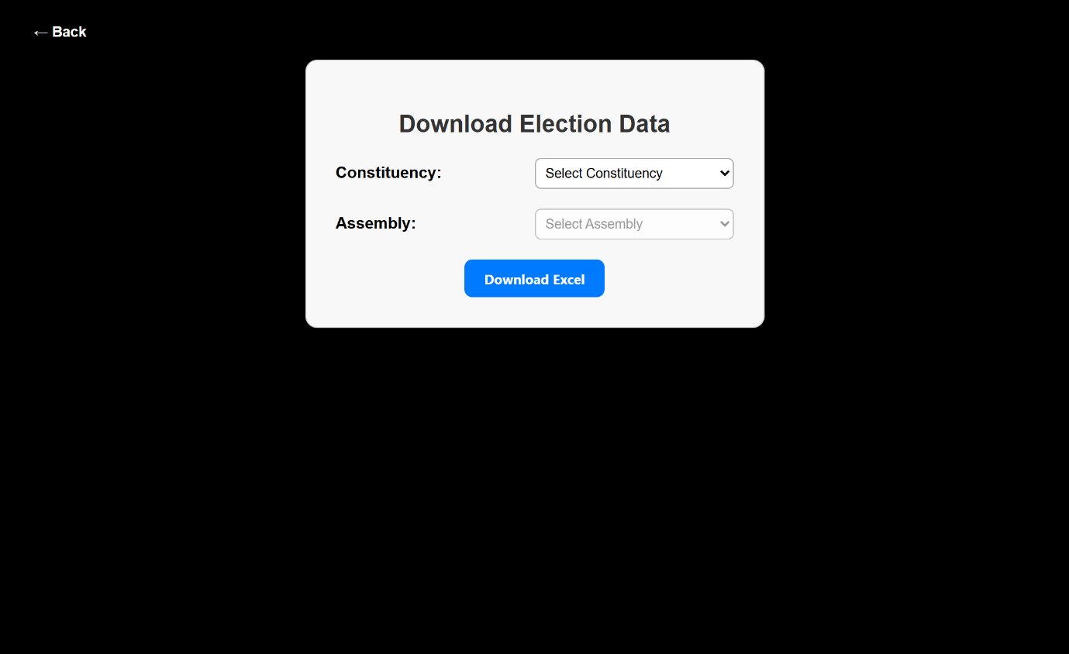

Election Results
In this section of the Election Results module, the user is provided with dropdown menus to select the Constituency and Assembly Number for which they want to download detailed election data. After selecting the desired constituency and assembly, the system automatically prepares the corresponding election results. A Download option is then made available, allowing the user to obtain the results in CSV format. This feature ensures easy access, portability, and compatibility with various data analysis tools, making it convenient for users to store, review, or process election statistics as needed.

